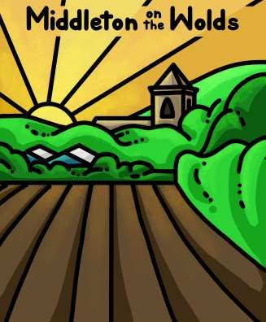

The Newsletter for Middleton on the Wolds

Issue No 43

NOVEMBER 2022

NEXT COPY DATE

14th NOVEMBER
Please send in your contributions by the end of each copy date. If I don’t acknowledge them please get in touch to make sure they have arrived.
Thank you
Lyn
4 The Paddocks 219500 middletonflyer@yahoo.com

ADVERTISING COSTS for the Messenger

Rates Month Year
Whole Page £25 £150
1/2 Page £15 £100
1/3 Page £10 £60

Private 1/4 page private advertisement - £5

Full colour - Print run 500 copies
Contact: Tina 01377 217242, middletonflyer@yahoo.com
See page 7 for details of the front page illustration.

Editorial
Well, that’s the end of summer, isn’t it? The clocks have gone back, and it’ll soon be dark before we get out of bed. But, hey, it’ll soon be Christmas!
Hopefully, you all enjoyed Halloween without eating too many sweets. Now it’s time to move on to the main event! I know the adverts have already started on the telly and that
you’ve been able to buy tins of Quality Street for what seems like months, but it will soon be Bonfire Night, after which we can legitimately start thinking about Christmas. Whatever did happen to Bonfire Night, anyway? I’m all for any excuse for a party, but how has Halloween taken over so comprehensively; and how did it happen so quickly? One minute it was ‘Penny for the Guy’, the next the shops were full of witches and pumpkins. Talk about being influenced by American culture – or have we just fallen for an ad man’s money-making scheme?
And, finally, what about Pippa Simpson’s new village logo on the front cover? I love it! It’s got the church, the trees, the hills, the fields; the farms and, as we all know, the sun always shines on Middleton! It would be good to see it used anywhere a village event is going on; or how about putting a shield up near the telephone box?
Just a thought!
Cheers
Mike
If you have any ideas, comments or complaints (especially complaints) you want to share then send an email to middletonflyer@yahoo.com.
Hi,
I just wanted to let you know that the allotment sheds have been broken into and to let people know via the messenger to be vigilant.
Kind regards
Rebecca

QUIZ PAGE
- What is the smallest US state by area?
- Which country is thought to have the most nuclear warheads?
- A Gibson is a type of what instrument?
- What is a group of rats called?
- Where in the human body is the ulna bone?
- Which band had hits with Parklife, Girls & Boys and Song 2?
- The main ingredient for a souffle is what?
With what did Samson kill 1000 philistines with, a sword, stones, or the
- jawbone of an ass?
- What was the name of Sherlock Holmes arch nemesis?
- What was the colour Elvis’s shoes?
Quiz set by Rowland Wooldridge
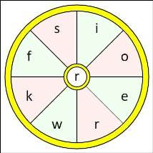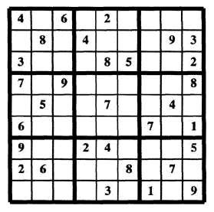
All answers on
page 27

SEASONAL WORD WHEEL

Try to find the timely word or words
and then create as many words
possible with the letters in the word
wheel. You can only use each letter
once and every word must include
the letter in the centre of the wheel.

SUDOKU

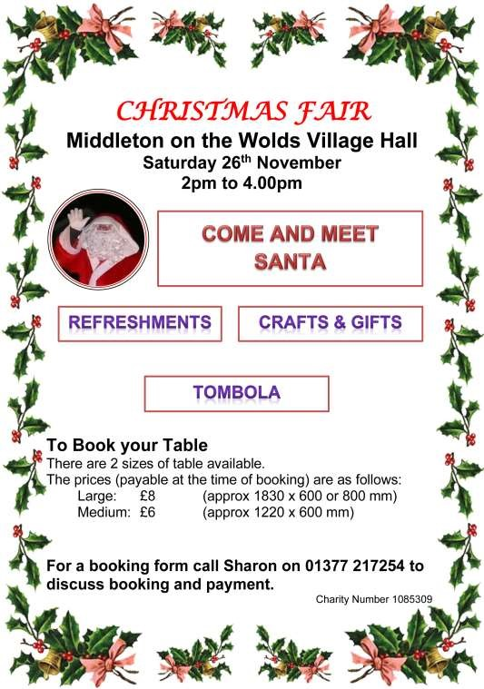

parish council news
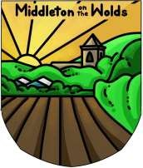
Thanks go to our wonderful village artist Pippa Simpson who has designed our village logo which will go on the shield hanging on the Jubilee Beacon. The logo may be used by anyone or organisation in the village that wishes to do so, just get in touch so that I can send you the jpeg file.
The Parish Council would like express their gratitude to Pippa for putting her talents and time into creating the logo.
Tina Walker Tinaalena@hotmail.co.uk Parish Councillor
VILLAGE HALL & RECREATION CLUB
CAKE DONATIONS

I am doing a cake stall for the Recreation Club, at the Village Hall fair 26th November.

I Would appreciate donations of cakes, if anyone can donate to drop off at my home before 11 am that day or we can collect.

Sharon
32 Orchard Drive 07976926855 or
E mail sharonmalc@hotmail.com
St Andrew’S church

Services for November
Sunday 6th | 10.30am | Morning Prayer. Roger
Sunday 13th | 10.30am | Remembrance Service. Rev’d Jane Anderson
 |  | All Welcome
Sunday 20th | 10.30am | Holy communion.
 |  | Rev’d Canon Kate Goulder
Sunday 27th | 10.30am | Morning Prayer. Chris

The wolds METHODIST CHURCH

Services for November
 | Sunday 6th 10.30am | Service at the Wolds Methodist Church.
 |  | Mrs Chris Crawford
 | Sunday 13th 10.30am | Remembrance Service at St Andrew’s Church
 |  | Middleton
 | Sunday 20th 10.30am | Service at the Wolds Methodist Church.
 |  | Rev Bill Anderson
 | Sunday 27th 10.30am | Service at the Wolds Methodist Church.
 |  | Pastor John Gleaves
COFFEE MORNING
at The Wolds Methodist Church Bainton Wednesday 16th November
10.00am to 11.30am All Welcome

a note from your vicar

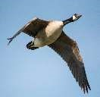
It’s time to fly
Over the past couple of weeks I have seen, and heard, many geese flying over Bainton and had always thought that this Autumn event was the beginning of their long journey to warmer shores – that was until I received an update email from the RSPB in which it informed me that many geese migrate here each year for our warmer climate. They arrive from Iceland,
Greenland and Canada to feed and over winter in our
estuaries, marshes and reservoirs. So, all these years when I have been waving goodbye and hoping they will have a safe journey over the 1000’s of miles ahead of them I should really have been saying ‘hello, glad you made it!’
Useful facts from the RSPB told me if geese are together on the ground they are a ‘gaggle’, in flight they are a ‘skein’ and many (though not all) fly in a ‘V’ formation because this conserves energy as the bird in front causes a slip stream with its wing beats which enables its companions to fly 70% further with the same amount of energy than flying alone would demand. And the loud honking they make is a way of encouraging the ones at the front to keep flying and also to help them keep a safe distance in their formation – real team work.
American writer Rachel Field penned this touching poem:
Something told the wild geese it was time to go.
Though the fields lay golden something whispered, — “Snow.” Leaves were green and stirring,
berries, luster-glossed, but beneath warm feathers something cautioned, — “Frost.” All the sagging orchards steamed with amber spice, but each wild breast stiffened at remembered ice.
Something told the wild geese it was time to fly,—
Summer sun was on their wings, Winter in their cry.

In the Christian Celtic tradition the Holy Spirit was represented by a wild goose – not the timid, gentle dove we may be more familiar with today.
‘Geese’ by Avis Palmer
This late-autumn afternoon they flew in kite-like formation, a trailing, living line across the blue-cold sky.

Honking loud encouragement, they are an aerial team where each one has a purpose and a place and each keeps faith with one intent.

Grounded, we feel the excitement of this annual sound and sight, rush outside to see their flight, wonder at an ancient rhythm, sense Love’s wild freedom, which is our calling too.

May we all find the time and space this month to feel excitement as we sense the ancient rhythm of our changing seasons.

Jane

HARVEST CHURCH LUNCH
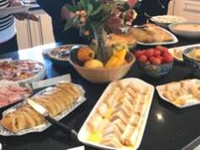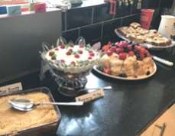
A selection of the wonderful food provided at the Harvest Church Lunch.

Middleton on the wolds ce ve school
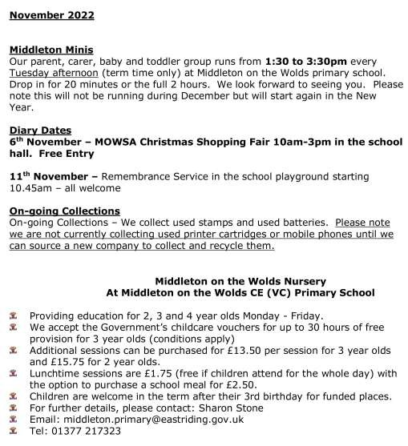
Executive Headteacher: Mrs E Harros

Station Road, Middleton on the Wolds, Driffield YO25 9UQ

E
-
mail:middleton.primary@eastriding.gov.uk Tel: 01377 217323

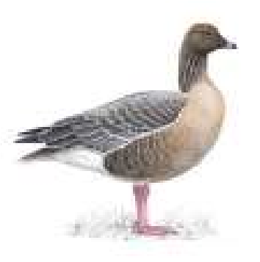
Local Birds & wildlife
“Season of mists and mellow fruitfulness…” well, I can’t remember how the rest of the poem unfolds (it being a while since I was at school) but there has been a bit of early morning mistiness and by all accounts lots fruitfulness is going on all over the village (apart from in my garden where the harvest from an apple tree, two pear trees and a cherry tree amounts to
Pink Footed Goose one eating apple.)
At the time of writing the fieldfares and redwings haven’t yet turned up to feast on the plentiful berries, but we have been treated to spectacular numbers of geese flying over the village! The Merlin app on my phone (a very useful free app to check bird calls) identified them as pink-footed geese, but there are probably greylag geese around as well. In the morning they have been heading north to feed, and then back south in the evening. I have heard them going over when it has been too dark to see them – how do they find their way? Apparently their night vision is 12 times better than ours, and as they can navigate by remembering landmarks they could well use the patches of lights from towns and villages to guide them, and if they are heading back to the banks of The Humber the water could be reflecting light from the moon and stars.
Although we haven’t seen any winter migrants yet, Janny and Barry have seen reports from elsewhere in the country (and also have plenty going on in their garden):
“Over the last three weeks there have been several sightings of redwings, bramblings and snow buntings as well as several rare warblers – they have started coming very early this year so let’s hope they come over here to Middleton. This week we have seen thousands of geese flying over the village. What a wonderful sight mornings and evenings. We have recently started seeing the marsh tits coming back to our feeders so let’s hope things have settled down after all the felling on the railway line. There are also lots of tree, hedge and house sparrows along with lots of finches coming to the feeders which we have up all year. Tawny owls have been calling on and off all day long on the railway line which seems unusual; normally it is afternoons and evenings. They are claiming their territory now their
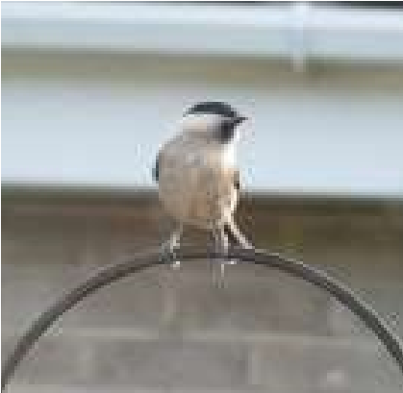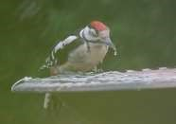
youngsters have gone.
”

As
well
as
their
observations
I
love
their
photos
of
the
marsh tit and a young
woodpecker
in
their
garden.

Fiona also got in touch with a lovely account of Stoat Action:
I thought you might be interested to hear that I saw two stoats (a pair?) at my field last week – I was just sorting out haynets for my horses and heard a chattering noise and they came tumbling across the paddock in front of me! Really lovely to see, and an animal I’ve not seen up there before. One of them did a big loop and headed back out into the field below mine, but the second one stopped, turned and watched me for several moments before disappearing into the undergrowth. And shortly after it went in, a rabbit came shooting out, so I suspect it was looking for dinner!”
Finally Tophill Low nature reserve is now partly open; it is still closed north of the visitor centre, but from there you can look out over the D reservoir (and there are very comfy sofas and a wood-burning stove!). Then the paths are open through the wooded area down to the O reservoir, and to several hides after that. I went as soon as it was open and got rudely shouted at by a Cetti’s warbler (a very small bird with an extremely loud voice) and stood next to a dead tree with a greater spotted woodpecker drumming right at the top, a sound which reverberated all the way down the trunk. And today Sheelah and I went and saw a black-necked grebe and some whooper swans, so it’s well worth a visit!
Please send me news of all your nature and wildlife sightings, or any comments about anything you would like to see on this page, or anything you would like me to do differently!
Barbara
Contact me on lavenderbarbara97@gmail.com or text 0777 192 7868
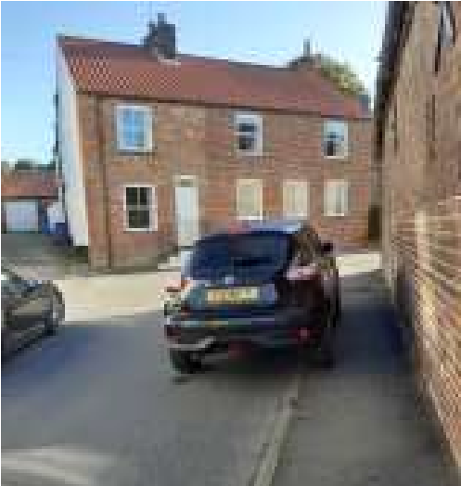

How to turn a hazardous corner
into a danger, not too mention
forcing pedestrians onto the road.

Inconsiderate or stupid?

Jim Wales

Thanks, Jim, a fair observation. What do the rest of you think? What do you think should be done about it? After all, it is your village.
Mike

LOCAL HISTORY

CIVIL WAR
“Cavaliers (wrong but wromantic)” “Roundheads (Right and Repulsive)”- Description from “1066 and all that” The famous 1930 comic romp through English history.
In 1605 a Catholic plot masterminded by Robert Catesby to blow up the House of Lords and derail the new Stuart dynasty was stopped at the last minute. Among the principal actors in this drama, which was provoked by parliament’s refusal to back James’s proposal to give greater freedom of worship to catholics, were local men; prominent was Guy Fawkes, a catholic convert, born in York near the present inn which bears his name and educated at St. Peter’s school. He was aided by Jack and Kit Wright, born in Welwick in Holderness and raised at Plowlands Farm. The enterprise
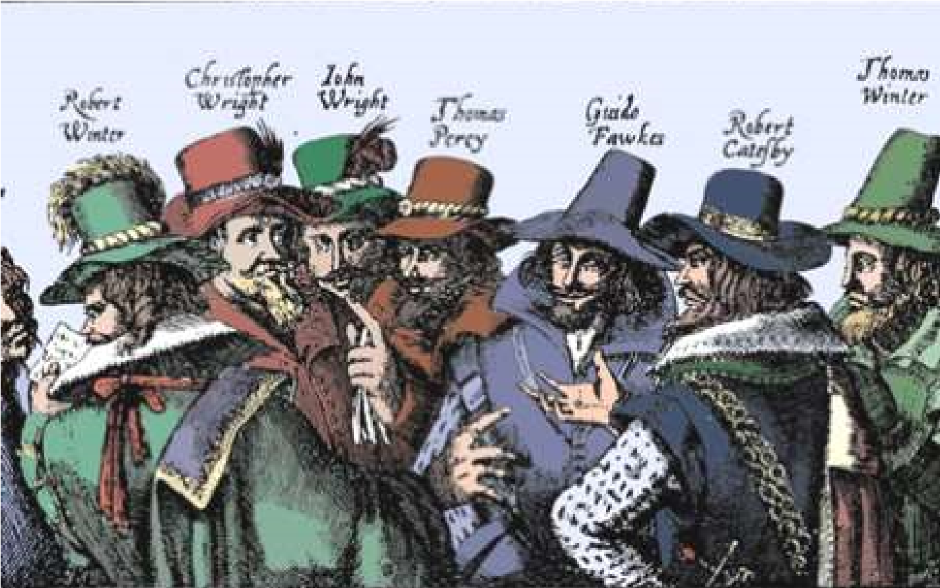
failed because of a breach in the plotters’ security; it is said that the inn and school have never celebrated Bonfire Night.

James the first had survived but was unsuccessful in his attemps to unify the three kingdoms under one system of civil and religious government and his successor Charles was even less likely to achieve these aims; a failure which proved a prime factor in the causes of the Civil War.

On Saturday the 23rd of April 1642 Charles the first, who was staying at Beverley, was refused admission to Hull by the governor Sir John Hotham of Scorborough, (who later changed sides); an act of defiance backed by force, taken along with an incident at Nottingham, as the start of the civil war.
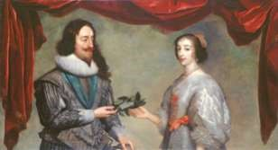
Charles had been a small, sickly child but had overcome his early deficiencies to become a cultured and brave man who was at the same time vain, stubborn and insensitive; he also aspired to be an absolute ruler. He married Henrietta Maria,
the catholic sister of Louis the thirteenth, king of France and welcomed catholics at his court, while he remained faithful to the more anglo-catholic part of the Anglican Church. His marriage was happy; his family life good; and he, unlike his father, presided over a well mannered court. His ambitions were, however, hindered by the lack of a standing army and an effective means of raising money without Parliamentary approval. One method tried was a forced loan to the king and in 1627 three Middleton men Robert Luttman, John Dayles, and Ralfe Witty were among those obliged to pay. In 1635 Charles extended the scope of the tax known as Ship Money to inland places when it had previously only been levied in coastal towns. On the 30th March 1640 the rate for Middleton for the building of two much needed ships of 480 tons apiece was £12. Nationally this tax provided one of the defining moments in the struggle when the famous John Hampden was tried for refusing to pay.

Whilst it is sometimes possible to know the allegiance of landowners in the county we are not able to be certain about the true sympathies of the common people and as John Buchan said “most Englishmen refrained from any decision and since the issue did not move them, abode in a puzzled neutrality.”

However all able bodied men aged 16 to 60 were liable for military service, armed with their own weapons and armour according to their income. A muster roll exists for Middleton in 1636 with the following names:

William Paulin John Lynal Brian Lukeupp
Nicholas Pickering John Dayley John Starke
Robert Gray William Elwald Philip Witty
Thomas Jaram Roger Manby William
Wilkinson

The war, with its combination of religion, power politics and fluctuating loyalties, could be a tedious affair; although in later centuries it did give scope to the desire of certain sturdy men with a love of action and loud noises to dress up and re-enact the more exciting battle scenes.

As the struggle progressed a leader, Oliver Cromwell, landowner and MP emerged on the parliamentary side; he was to become one of the most contentious figures in British history. A brilliant military tactician, one of whose first achievements when in command of the cavalry on Fairfax’s left wing was the defeat in 1644 of the royalist army at Marston Moor seven miles west of York. He was also instrumental in the creation of The New Model Army, that most feared and efficient force. Cromwell, a complex character, was unique in being a commoner who went on to oust a king and become head of state but who, for all his flirtations with what passed as the left in political thinking of those times, remained a landowner with a landowner’s outlook. He also carried the guilt for the execution of the king.

In the next article we will look at the further effects on the people of Middleton and locality

Geoff Wisher

Village produce show
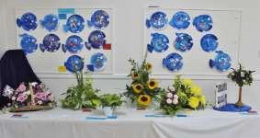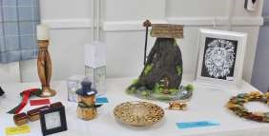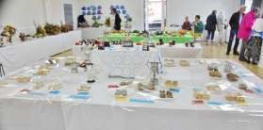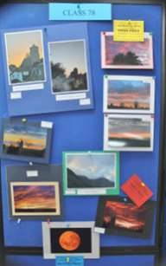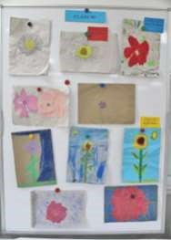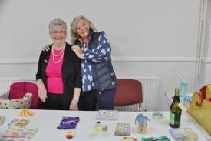
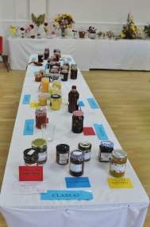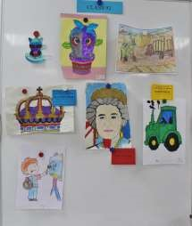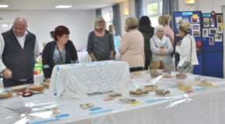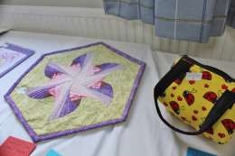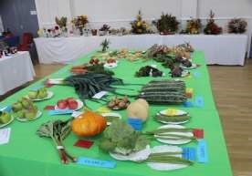
Photos taken by Tina & Lynn Walker

Yorkshire veterans model group
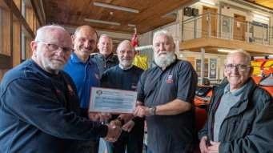

The Yorkshire Veterans Model Group was set up to help veterans of all our armed forces and blue-light emergency services with an interest in model making.

We're a club for Veterans, run by Veterans and our group meetings and workshops aim to develop or reawaken an interest in making models from plastic and other materials. Modelling groups provide Veterans with a place to meet and share their interests in a social and friendly atmosphere, gaining a sense of belonging and shared values in a world where social isolation is all too common. Making models has proven therapeutic values and is now frequently used in several Ministry of Defence rehabilitation programs for those recovering from life-changing injuries. Our YVMG is totally selffunding and relies on donations and gifts of model kits to allow a return to the modelling bench for many.

However, it is not all one way! We recognise there are many more worthy organisations deserving of support in our coastal community including the RNLI which provides an essential, voluntary service to safeguard the welfare of those who enjoy our coast and seas. Every year, more people rely on RNLI lifesavers to rescue those who may find themselves in a life-or-death ordeal. The Yorkshire Veterans Model Group has adopted the Bridlington Lifeboats (RNLI) as our chosen charity and we are pleased to confirm our first donation of £200 was presented on Wednesday 28th September at the Bridlington Lifeboat Station, Spa Promenade. Thank you to everyone who donated and took part in our recent fundraising auction to make this and future support possible.

Ian Dewar
Founder: Yorkshire Veterans Model Group
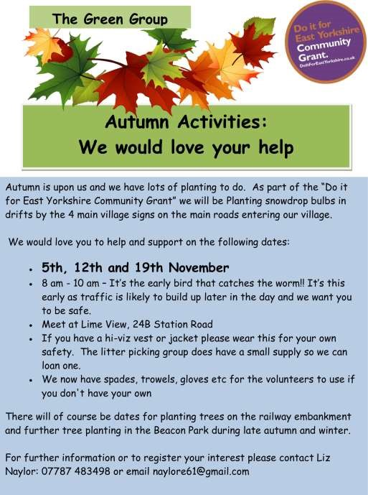
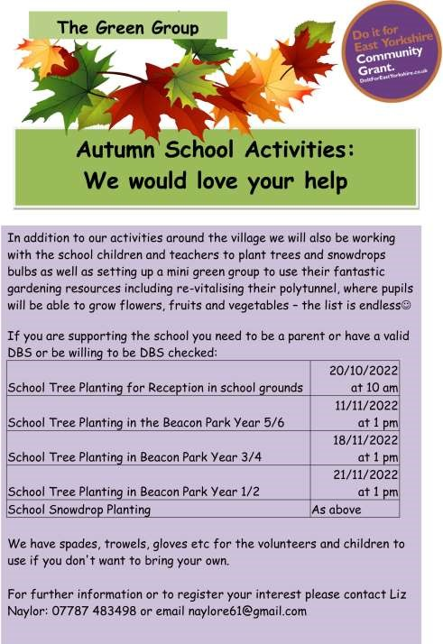

Middleton book group

Code Name Hélène by Ariel Lawhon

In 1936, foreign correspondent, Nancy Wake, witnesses firsthand the terror of Hitler’s rise in Europe. No sooner has Nancy met, fallen in love with and agreed to marry French industrialist Henri Fiocca, than the Germans invade France and force her to take on her first code name of many. The Gestapo call her the White Mousefor her remarkable ability to evade capture when smuggling Allied soldiers across borders. She becomes Hélène when she leaves France to train in espionage with an elite special forces group in London. Then, when she returns to France, she is the deadly Madame Andrée. But the closer France gets to liberation, the more exposed Nancy – and the people she loves – will become.

Inspired by true wartime events, Code Name Hélène is a gripping and moving story of extraordinary courage, unfaltering resolve, remarkable sacrifice – and enduring love.

I couldn't believe that Nancy Wake isn't an international household name. I found her story extraordinary and inspirational.

The Age of Miracles by Karen Thompson Walker

WHAT IF our 24-hour day grew longer, first in minutes, then in hours until day becomes night and night becomes day?

What effect would this slowing have on the world? On the birds in the sky, the whales in the sea, the astronauts in space, and on an eleven-year-old girl, grappling with emotional changes in her own life...?

One morning, Julia and her parents wake up in their suburban home in California to discover, along with the rest of the world, that the rotation of the earth is noticeably slowing. The enormity of this is almost beyond comprehension. And yet, even if the world is, in fact, coming to an end, as some assert, day-to-day life must go on. Julia, facing the loneliness and despair of an awkward adolescence, witnesses the impact of this phenomenon on the world, on the community, on her family and on herself.

'It is never what you worry over that comes to pass in the end. The real catastrophes are always different - unimagined, unprepared for, unknown...'

A beautiful novel of catastrophe, survival, coming of age , growth and change. Quite unike anything I've ever read before or since. I think it's an excellent read.

Amanda

The next books for discussion: The Herring Girl by Debbie Taylor
All My Mothers by Joanna Glen

Meetings are on the second Tuesday in the month in member’s homes - Contact
Lyn for further details: 219500 or lyndennis456@gmail.com
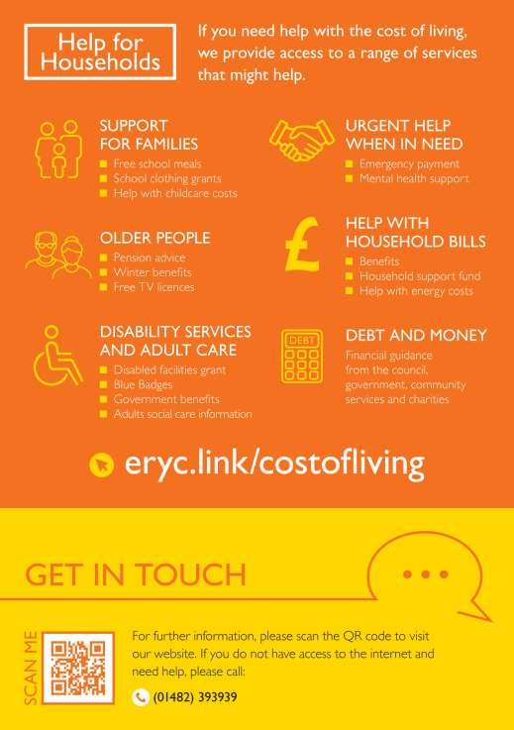

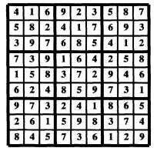
FIREWORKS

QUIZES
1

Rhode Island

2

Russia

3

Guitar

4

Mischief

5

Forearm

6

Blur

7

Eggs

8

The jawbone of an ass

9

Moriarty

10

Blue (suede shoes)

Advertisement

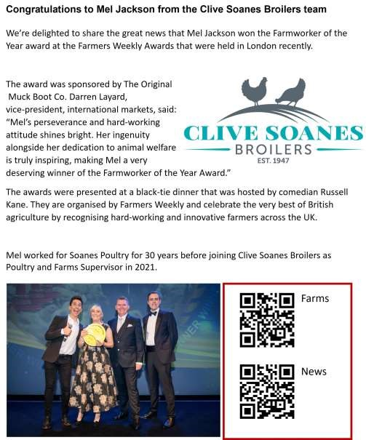
Advertising Feature

Advertisements
Advertisement

Advertising Feature
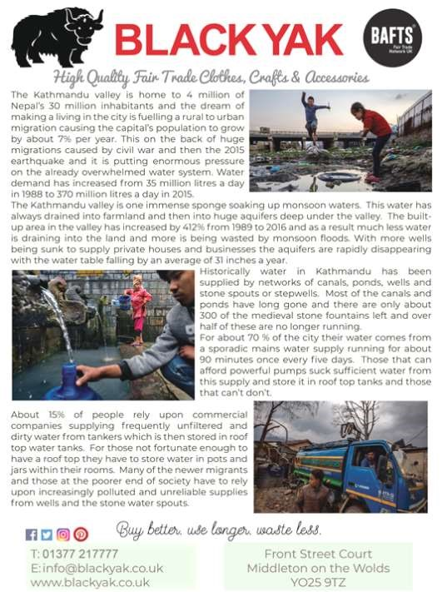
Regular group activities
LOCAL CONTACTS Bell Ringing Chris Atkin |  | 217285
Book Group/Middleton Movers | Lyn Dennis | 219500
Bowls Club | Rob Bradley | 217435
Country Women’s Association | Christine Johnson | 217374
First Responders | Chris Brent | 219469
Line Dancing | Pat Pottage | 217516
Methodist Chapel | Jane Gray | 07870 562455
Middleton Messenger | Mike Kelly | 07713 620912
 | Lyn Dennis | 219500
 | Tina Walker | 217242
Middleton Green Group | Liz Naylor | 219072
Middleton Womblers | Andrew Naylor | 219072
Parish Clerk | Sandra Morrison | 01262 470496
Pilates | Ian Stephenson | 07973 755717
Recreation Club | Dave Newlove | 07901 833784
St Andrew’s Church | Rev Jane Anderson | 219471
St Andrew’s Church Wardens | Chris Brent | 07766 162743
 | Lesley Kelly | O7907 451046
Village Hall | Lyn Dennis | 219500
Village History Geoff Wisher |  | 217517
7 | Parish Council |  | 7.00pm | Village Hall
8 | Book Group |  | 10.30am | St Andrew’s Close
17 | YCA |  | 7.30pm | Village Hall
27 | Litter Picking |  | 10.00am | Lime View

Weekly Groups
Monday Pilates | 5.00-6.00pm | Village Hall
Tuesday Tai Chi | 2.30-4.00pm | Village Hall
Wednesday Line Dancing | 7.30-9.00pm | Village Hall
Thursday Middleton Movers | 2.00-3.30pm | Village Hall

November

